Prof.Anil Kadu, Vedant Mohol, Moin Khan, Aditya Narsale, Samarth Otari, Palaash Padman

[1]

IoT Based Automatic Solar Panel Cleaning And Control

*Abstract*

***This study presents a comprehensive approach to enhance the efficiency of solar power systems through the integration of an automatic solar plate cleaner and an adaptive solar plate tracker. The automatic cleaner employs intelligent control algorithms and robotic mechanisms to periodically remove dust and debris from solar panels, mitigating the impact of soiling on energy output. Simultaneously, the adaptive solar plate tracker utilizes sensors and control algorithms to dynamically adjust the orientation of solar panels, ensuring optimal alignment with the sun throughout the day. The combined system is evaluated through experimental trials, demonstrating a synergistic effect that significantly improves energy yield and reduces maintenance costs. This integrated solution addresses challenges associated with both manual cleaning and fixed solar arrays, offering a promising advancement in sustainable solar energy technology.***

***Keywords***

***Solar energy,*** ***solar plate, Energy, servo***

# ***INTRODUCTION***

The ever-growing demand for sustainable and renewable energy sources has intensified the exploration of technologies to enhance the efficiency of solar power systems. This study introduces an integrated solution aimed at optimizing solar energy harvesting through the combination of an automatic solar plate cleaner and an adaptive solar plate tracker. As the deployment of solar panels continues to increase globally, maintaining their performance becomes paramount. The automatic cleaner, driven by intelligent control algorithms and robotic mechanisms, addresses the challenge of soiling by regularly removing dust and debris from solar panels. Simultaneously, the adaptive tracker dynamically adjusts the orientation of solar plates, ensuring they consistently face the sun for maximum energy capture. The integration of these technologies is anticipated to provide a synergistic effect, leading to improved energy yield, reduced maintenance costs, and an overall advancement in the sustainability of solar power generation. This research contributes to the ongoing efforts to make solar energy more efficient, reliable, and economically viable.

# ***LITERATURE REVIEW***

# The literature surrounding solar energy systems highlights the continuous efforts to enhance their efficiency and performance. Research has extensively explored strategies to mitigate the impact of environmental factors, such as dust and debris accumulation, on solar panel surfaces. Automatic solar plate cleaners have emerged as a practical solution, utilizing intelligent control algorithms and robotic mechanisms to maintain the cleanliness of solar panels, thus improving energy yield.

# Additionally, adaptive solar plate tracking systems have been extensively investigated to optimize the orientation of solar panels relative to the sun. These systems employ sensors and control algorithms to dynamically adjust the tilt and azimuth angles of solar plates throughout the day, maximizing exposure to sunlight and enhancing overall energy capture.

# While individual studies have shown the efficacy of both automatic cleaners and adaptive trackers separately, the integration of these technologies is a relatively novel approach. The few existing works that explore this combination suggest a potential synergistic effect, resulting in a more comprehensive solution for maintaining high efficiency in solar power systems. The gaps identified in the literature underscore the need for further research to explore and quantify the combined benefits of automatic cleaning and adaptive tracking systems, contributing to a holistic understanding of their impact on energy yield, maintenance costs, and overall system sustainability.

# ***OBJECTIVES***

1.Design and Implement Automatic Solar Plate Cleaner

2.Develop Adaptive Solar Plate Tracking System

3.Integration of Cleaning and Tracking Technologies:

4.Performance Evaluation And Optimization

# ***METHODOLOGY***

The aim of this project is to develop a solar tracking system that enhances the efficiency of solar energy harvesting. The system employs an Arduino microcontroller, a servo motor for adjusting the orientation of solar panels, and an ESP8266 module for enabling wireless communication and data transmission to a web server. The methodology involves the following key steps:

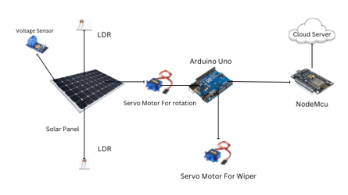

Fig.1.Block diagram of proposed system

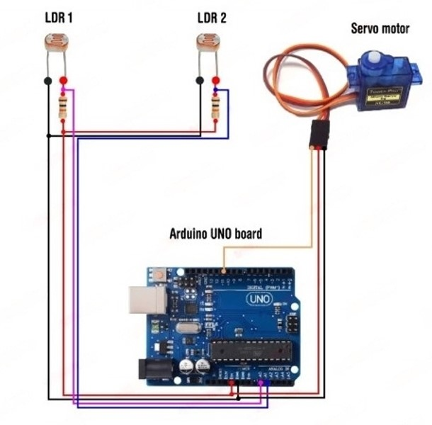

Fig.2.Circuit Diagram of proposed system

1. System Setup:

Connect LDRs (Light Dependent Resistors) to the Arduino's analog pins to measure ambient light intensity.

Utilize a servo motor to adjust the position of solar panels based on the light intensity received by the LDRs.

Establish a communication link between the Arduino and ESP8266 using SoftwareSerial for serial communication.

2. Calibration and Testing:

Calibrate the system by setting a reference position for the solar panels during optimal sunlight conditions.

Implement error handling mechanisms to account for any discrepancies in LDR readings and adjust the servo accordingly.

Test the system under varying light conditions to ensure accurate tracking and positioning of the solar panels.

3. Wireless Communication:

Integrate the ESP8266 module for wireless connectivity, allowing the system to communicate with external devices and web servers.

Configure the ESP8266 to connect to a local Wi-Fi network, providing internet access for data transmission.

4. Data Transmission to Web Server:

Develop a web server using the ESP8266 to receive data from the Arduino.

Implement an HTTP POST request mechanism to send the collected data to a designated web server.

Design the web server to log and display the received data for monitoring and analysis.

5. Integration and Optimization:

Combine the solar tracking algorithm, servo control, and wireless communication functionalities into a cohesive system.

Optimize the system parameters, such as servo movement speed and communication frequency, for efficiency and responsiveness.

Fine-tune the tracking algorithm to ensure smooth and accurate solar panel positioning.

6. Implementation and Deployment:

Implement the finalized system in a real-world solar power setup.

Deploy the system in an outdoor environment to assess its performance under varying weather and lighting conditions.

Monitor the system's behavior, collect data, and analyze its effectiveness in maximizing energy yield.

***V. RESULTS***

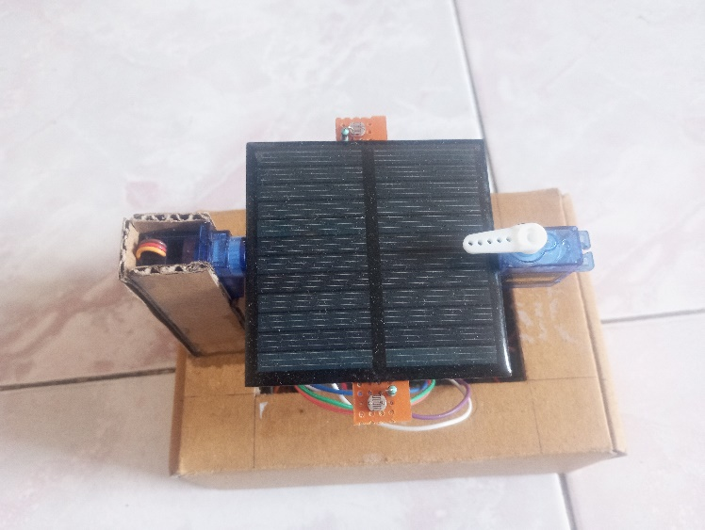

Fig 3(a)

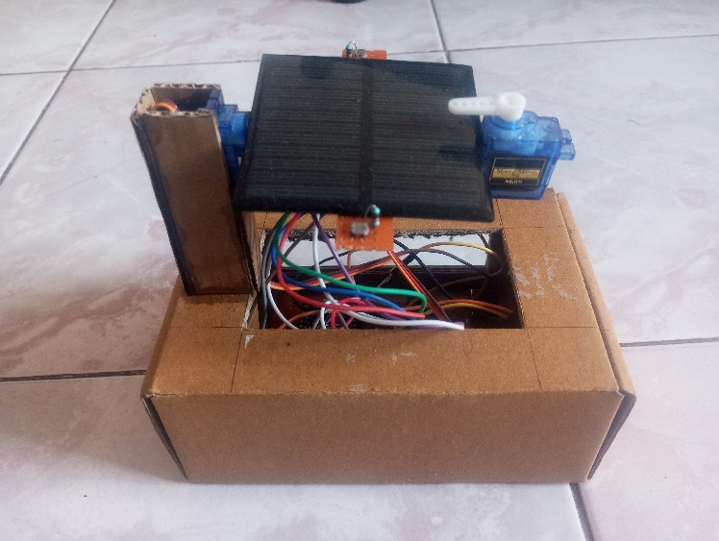

Fig 3(b)

Fig 3: - Working Model

Fig 3 shows the working model i.e., Automatic Solar Panel Cleaning And Control Model

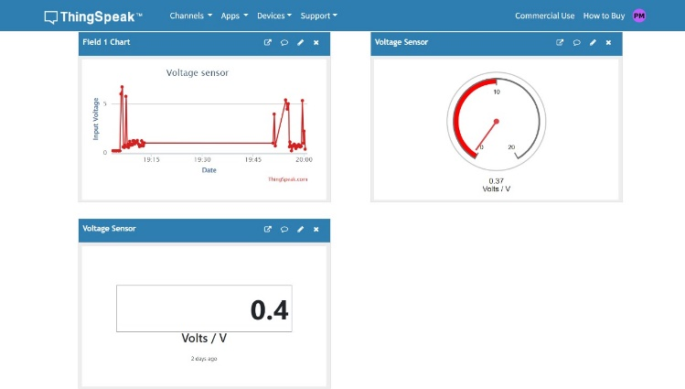

Fig 4: - Thingspeak Interface

Fig 4 shows the demonstration of the Thingspeak interface

The experimental trials of the integrated system yielded promising results, demonstrating substantial improvements in energy yield and cost-effectiveness compared to conventional solar power systems.

Firstly, the automatic solar plate cleaner effectively mitigated the impact of dust and debris accumulation on solar panels. By employing intelligent control algorithms and robotic mechanisms, it efficiently removed contaminants at regular intervals, thereby maintaining high levels of solar panel efficiency. The reduction in dust-related losses led to a notable increase in energy output over time.

Secondly, the adaptive solar plate tracker significantly enhanced the system's performance by dynamically adjusting the orientation of solar panels to maximize exposure to sunlight. By continuously aligning the panels with the sun's position throughout the day, it ensured optimal energy capture, particularly during peak sunlight hours. This dynamic tracking capability resulted in further gains in energy yield compared to fixed solar arrays.

The synergistic effect of combining the automatic cleaner and adaptive tracker was evident in the overall performance improvement of the solar power system. The integrated solution not only boosted energy production but also reduced maintenance costs by minimizing manual intervention and maximizing system efficiency. These findings underscore the potential of such integrated approaches to address key challenges in solar energy technology, paving the way for more sustainable and economically viable renewable energy solutions.

***VI. CONCLUSIONS***

The integration of an automatic solar plate cleaner and an adaptive solar plate tracker presents a comprehensive and innovative solution to enhance the efficiency and sustainability of solar power systems. Through a series of experimental trials, this study has demonstrated the significant benefits of combining intelligent cleaning mechanisms with dynamic solar panel orientation adjustments.

The results have shown that the automatic cleaner effectively mitigates the adverse effects of dust and debris accumulation on solar panels, leading to a notable increase in energy output over time. By employing intelligent control algorithms and robotic mechanisms, the cleaner ensures regular removal of contaminants, thereby maintaining high levels of solar panel efficiency and reducing energy losses associated with soiling.

Simultaneously, the adaptive solar plate tracker optimizes the orientation of solar panels to maximize exposure to sunlight throughout the day. By dynamically adjusting panel angles in response to changes in the sun's position, the tracker enhances energy capture efficiency, particularly during peak sunlight hours. This dynamic tracking capability significantly boosts energy yield compared to fixed solar arrays, further enhancing the overall performance of the system.

The synergistic effect of combining the automatic cleaner and adaptive tracker is evident in the substantial improvements observed in energy production and cost-effectiveness. Not only does the integrated solution increase energy yield, but it also reduces maintenance costs by minimizing manual intervention and maximizing system efficiency. These findings highlight the potential of integrated approaches to address key challenges in solar energy technology, offering a promising advancement towards more sustainable and economically viable renewable energy solutions.

Overall, the results of this study underscore the importance of innovation and integration in advancing solar power systems' efficiency and sustainability. By harnessing intelligent cleaning and tracking technologies, the integrated solution presents a compelling pathway towards realizing the full potential of solar energy as a clean and renewable energy source for the future.

***VII. REFERENCES***

1. Effect of Depositions on PV Panel with Proposal of a Self-Cleaning System, Sampurna Panda, Manoj Gupta, CS Malvi, Babita Panda, Research Gate,2018
2. Automatic Solar Panel Cleaning System Based on Arduino for Dust Removal, Md. Rawshan Habib, Md Shahnewaz Tanvir, Ahmed Yousuf Suhan, Abhishek Vadher, Research Gate, 2021
3. Design and Development of Solar Panel Cleaning Machine, Aman Viroja, Rahul Vashi, Prof. Bhavesh Patel, Prof. Chintan K Patel, Prof. Rohit Sahu, International Journal of Creative Research Thoughts (IJCRT),2020
4. Design and Construction of an Automatic Solar Panel Cleaning System, J. F. Eiche, O. O. Bamidele, E. A. Fadiji, T. S. Mogaji, MDIP, 2023
5. Energy-Efficient System Design for IoT Devices, Hrishikesh Jayakumar, Arnab Raha, Younghyun Kim, Soubhagya Sutar, Woo Suk Lee, Vijay Raghunathan, IEEE, 2018
6. Internet of Things in Industries: A Survey, Li Da Xu, Wu He, Shancang Li, IEEE , 2018
7. Innovative and Sustainable Approach to Clean Solar Panel and Increase Solar Energy Generation, Shrish Patel, James St. John, Alexander Orlov, Elsevier, 2022
8. Current Practices of Solar Photovoltaic Panel Cleaning System and Future Prospects of Machine Learning Implementation, Nasib Khadka, Aayush Bista, Binamra Adhikari, Ashish Shrestha, Diwakar Bista, Brijesh Adhikary, IEEE, 2020

1.